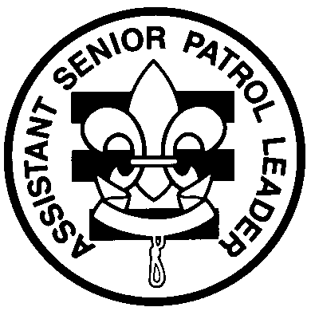

Troop 2
http://www.troop2.org

Assistant Senior Patrol Leader Handbook
Troop 692

Name: __________________________

Contents:

Assistant Senior Patrol Leader Leadership Card
Assistant Senior Patrol Leader PLC Report

- Enter your name and the date that you started this position.
- Read and understand the enclosed material.
- Photocopy and use enclosed forms where appropriate.
- Bring this binder with you when you have a job review or board of review.
- Each month the Scout will be reviewed as to whether he “met”, “needs improvement” or “did not fulfill the requirements” of the position
Name | Start Date | End Date
Monthly Review

Assistant Senior Patrol Leader Leadership Card

Job Description: The Assistant Senior Patrol Leader is the second-highest-ranking junior leader in the troop. The senior patrol leader, with the approval of the Scoutmaster, appoints him. The assistant senior patrol leader acts as the senior patrol leader in the absence of the senior patrol leader or when called upon. He also provides leadership to other junior leaders in the troop.

Leadership Position Coordinator: The Senior Patrol Leader

Duties of Assistant: Senior Patrol Leader:
- Lives the Scout Oath and Law.
- Sets a good example.
- Shows Scout Spirit.
- Lead, Train and Inspire
- Enthusiastically wears the Scout uniform correctly.
- Is usually one of the older Scouts in the troop
- Appointed by the Senior Patrol Leader (SPL).
- A new ASPL is appointed every 6 months.
- Must have attended Youth Leader Training (YLT) before or shortly after election.
- Utilizes skills learned at YLT.
- Obtain a copy of the Senior Patrol Leader Handbook and read it.
- Must be a visible leader at troop meetings, camp outs and other activities.
- Effectively communicates both verbally and electronically to youth and adults
- Works with the Scoutmaster, Assistant Scoutmasters and youth leadership to ensure that all Scouts receive the help they need for advancement.
- Serves as a member of the Patrol Leader Conference (PLC).
- Has the Assistant Senior Patrol Leader’s report to the PLC prepared upon arrival at the PLC.
- Helps with leading meetings and activities as called upon by the SPL.
- In the absence of the senior patrol leader, runs the troop during PLC, troop meetings, campouts or other activity
- Uses TroopTrack to help manage the troop including PLC meetings, troop meetings, camp outs and other activities through the use of the RSVP and reporting systems.
- Helps train and supervise the troop scribe, quartermaster, librarian, webmaster/historian, bugler, and chaplain’s aide.
- Helps perform job reviews for the troop scribe, quartermaster, librarian, webmaster/historian, bugler, and chaplain’s aide.
- And all other duties assigned

Assistant Senior Patrol Leader PLC Report

Think: What have the other troop officers been doing?

Chaplain Aide:
Did the Chaplain Aide go on the last campout?
Did he perform a Sunday service?
Did he do a prayer to open and close each meeting this past month?

Librarian:
Is the library up-to-date?
Did he show you the current list of what merit badge books we own and what merit badge books we need to get?
Did he show you the merit badge check-out log book?
Did he show you the list of current release date for all merit badge books?
Has he clearly marked all the merit badge books that are no longer current?

Historian/Webmaster:
Did the Historian go on the last campout?
Did he take any pictures at the last campout?
Did he record what we did at last month’s campout in his Troop Journal?

Scribe:
Did the scribe attend the meeting?
Did the Scribe take role?
Did the Scribe attend PLC and take minutes?
Did the Scribe distribute minutes from PLC?
Did the Scribe take attendance at activities and turn in to SPL?

Quartermaster:
Did the quartermaster attend camp out?
Did the quartermaster conduct pre and post inventory….check out of trailer in/out?
Did the quartermaster report on any damaged or lost equipment in his report to PLC?
Did the quartermaster request any needed new equipment to PLC?

